**CLASSIFICATION OF NEURODEGENERATIVE DISORDER USING CONVOLUTIONAL NEURAL NETWORKS**

**Danish Khan, Dr. R. Sreemathy*, Kisley Chandra, Tejas Bora**

Department of Electronics and Telecommunication, Pune Institute of Computer Technology, Pune, India

*Email: rsreemathy@pict.edu

***ABSTRACT***

*Neurodegenerative disorders are one of the most insidious disorders that affects millions around the world. Presently, there is no cure for these disorders, however, if diagnosed at an early stage, therapy can prevent further degeneration. The proposed study aims to detect the early onset of one such neurodegenerative disorders called Alzheimer’s Disease, which is the most common neurodegenerative disorder. The MRI scans are from the OASIS-1 dataset obtained from the Open Access Series of Imaging Studies (OASIS). These MRI scans are pre-processed by applying various filters, namely, High-Pass Filter, Contrast Stretching, Sharpening Filter, and Anisotropic Diffusion Filter, in order to enhance the images. The proposed Convolutional Neural Network (CNN) model, and AlexNet, are trained using these pre-processed MRI images, and their results are evaluated, after which, the diagnosis is generated. The proposed CNN model achieves an accuracy of 99.21%, with a precision of 0.9844, and recall of 1.00, by using a combination of filters in the pre-processing stage, which are, Sharpening filter, followed by Contrast Stretching, and lastly an Anisotropic Diffusion Filter.*

***Key words: Alzheimer’s Disease, High-Pass Filter, Contrast Stretching, Sharpening Filter, Anisotropic Diffusion Filter, AlexNet.***

1. **INTRODUCTION**

The brain undergoes development throughout its life. These developments occur in order to adapt to the everchanging surroundings. Over the course of a lifetime, it is observed in some cases that the brain undergoes degeneration, which results in damage or loss of brain cells. These disorders are termed as Neurodegenerative Disorder, such as, Alzheimer’s Disease, Parkinson’s Disease, Epilepsy, etc. According to the World Health Organization, 50 million people suffer from dementia, with 10 million new cases being added each year. Alzheimer’s Disease is the most common form of dementia and contributes to roughly 60-70% of cases. While, a cure is not yet available, if the disorders are detected at an early stage, it is possible to slow down the degeneration, through therapy. At older ages, it is possible to detect these diseases due to loss of significant amount of brain cells, but it is often too late to begin preventive measures.

With the use of neuroimaging, it is possible to explore the brain to a great extent. Due to the recent developments in the neuroimaging techniques, the early onset of such disorders can be detected. However, it is difficult to interpret these brain scans and draw meaningful inferences due to the high complexity of this data. It usually takes a medical expert 12 to 24 months to analyse months of scans of a patient to detect a significant degeneration, in addition to several other tests that are performed to diagnose the disease [2]. The diagnosis process can be accelerated by highlighting the biomarkers, that help identify the degeneration of the brain, which can be done by pre-processing the MRI scans. The diagnosis of the disease can be done by training a Neural Network model, which can produce results in the matter of seconds, thereby saving time and resources.

The MRI images obtained from the OASIS-1 dataset consist of two views, Sagittal, and Axial (transverse) view of the subject’s brain. Fig. 1 represents the Axial and the Sagittal views of a subject’s brain as observed in an MRI scan.

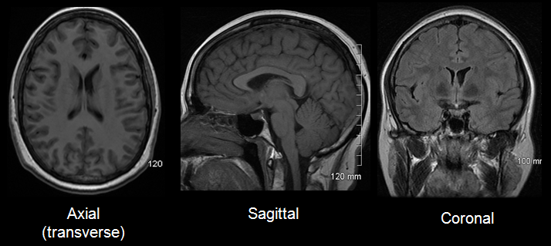

**Fig. 1.** Axial (transverse), and Sagittal views of brain in a MRI scan.

Fig. 2 highlights the Hippocampus region of the brain which is the Region of Interest, and a change in volume and shape of the Hippocampus is one of the biomarkers for Alzheimer’s disease. This can be identified by taking a closer look at Fig. 2, and comparing the upper half of the image with the lower half, where it can be observed that there is a significant change in the volume, as a result of cell degeneration in the brain. Therefore, identifying this change is of utmost importance to diagnose the disease.

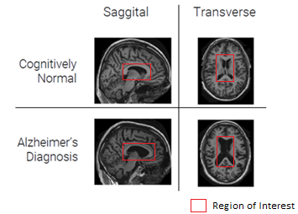

**Fig. 2.** Difference between a Cognitively Normal Patient’s Brain, and Alzheimer’s Disease Patient’s Brain

1. **LITERATURE REVIEW**

Key statistics and figures of the number of active dementia cases and the number of new cases added each year, provided by the World Health Organization, can be found on their official website [1]. The various methods that are employed to diagnose Alzheimer’s disease, and the role MRI scans play in diagnosis are obtained from Mayoclinic’s website [2]. The dataset used was obtained from the Open Access Series of Imaging Studies (OASIS) [3]. The study by Gerardin E. [4] shows the parts of the brain which are affected by Alzheimer’s Disease, which can be observed in MRI scans. The two most distinct part of the brain where there is significant loss of grey-matter are: the Lateral Ventricle, and the Hippocampus. From the Gerardin E’s study [4], and the article published on Mayoclinic’s website [2] we can conclude that the loss in grey-cells, or their atrophy can be used as an effective biomarker for the diagnosis. The research by Shijie L. et al, [5] shows how an improvement in performance of a Convolution Neural Network can be achieved by increasing the size of the training dataset by flipping, cropping, and rotating the MRI images. The study published by Khagi et al., [6] shows that Convolutional Neural Networks, and pretrained Models are an effective tool in diagnosing brain disorders. The research by Khagie et al.[6], and Zingale R. et al [7] use pre-processing techniques such as Anisotropic Diffusion Filter, and Contrast Stretching Filter to improve the MRI scans and obtain better classification. A comparison of the classification results obtained on the OASIS dataset, by Basheer S. et al., using MCapNet [8] and Gerardin E. [4] using AlexNet, along with the proposed Convolutional Neural Network are mentioned in the results section. Equations (8) through (11) were obtained from the original study [9] authored by P. Perona and J. Malik.

1. **PROPOSED METHODOLOGY**

MRI brain scans are used in the proposed methodology, since these scans can be taken quickly and are accessible to the general population. With the implementation of the right model, these scans help differentiate a healthy brain from a brain with the early onset of the disease, as well as a brain that’s been severely affected, and obtain accurate results in shorter span of time, while removing any human error in the process. This can be done by using image processing techniques and by using deep learning algorithms on the dataset that is accessible.

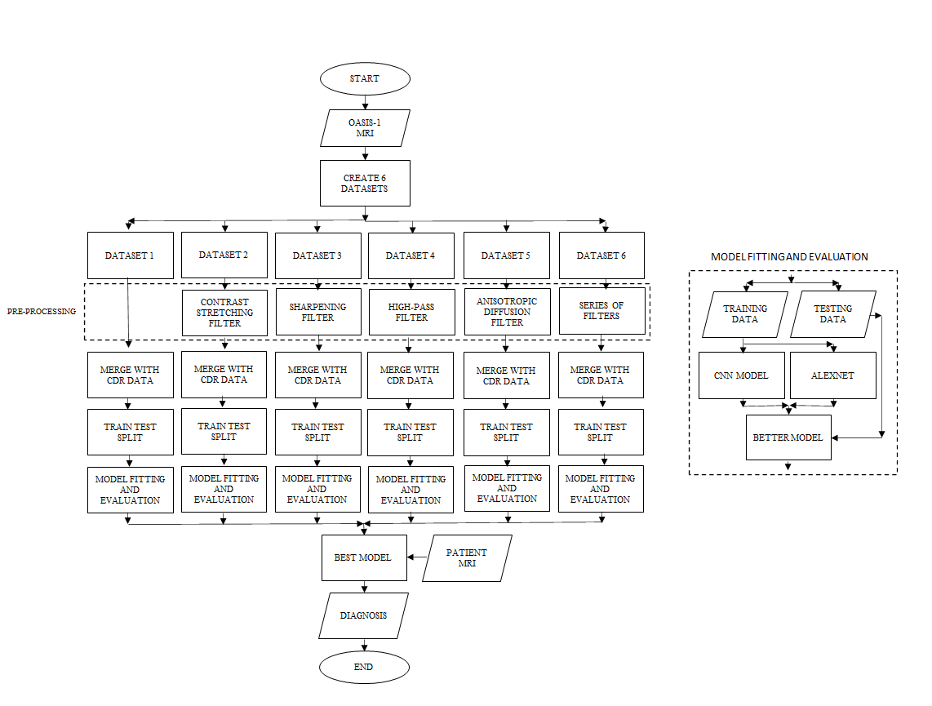

**Fig. 3.** Flowchart of the proposed methodology.

Fig. 3 shows the proposed methodology. The MRI scans obtained from the OASIS-1 dataset, contain both sagittal, as well as the transverse views of the brain. In the first case, sagittal MRI is used. Six copies of the dataset are created, and each copy is passed through one of the five pre-processing filters, while no pre-processing is applied on one dataset-copy. After pre-processing, each dataset is merged with the Clinical Dementia Rating (CDR) Data, which is essentially the diagnosis of the patient. CDR is in the range of 0 to 5, with 0 representing a healthy patient, and 5 representing a patient with a severe case of Alzheimer’s Disease. Each dataset is split into training, and testing data, in the ratio 80:20 respectively. Following the train-test split, one copy of each training dataset is passed through the Proposed Model, and another copy through the AlexNet model. After training on the two models, the testing data is fitted onto both models and their results are compared. The best model amongst all trained models is selected, and the Patient’s (end-user who is to be diagnosed) MRI scans is passed through the model, and the diagnosis is generated.

1. **PRE-PROCESSING THE MRI SCANS**

***4.1 Contrast Stretching Filter***

Contrast can be increased in an image by using an image enhancement technique called Contrast Stretching, also referred to as normalization. This is achieved by `stretching' the contrast levels in the image over a desired range of intensity values. It is different from histogram equalization as scaling function that it applies to the image pixel values is linear, which results in the enhancement being less harsh than that of histogram equalization.

The upper- and lower-pixel value limits of the image to be normalized, is to be specified. For an 8-bit graylevel image, the lower and higher limits are 0 and 255. The lower and the upper limits are taken as a and b respectively. The program proceeds to scan the image to identify the lowest and highest pixel values present within the image and saves them as c and d respectively. Then every pixel P is scaled by the subsequent equation (1):

(1)

Fig. 4 shows the comparison between the MRI scans before and after the application of the Contrast Stretching Filter.

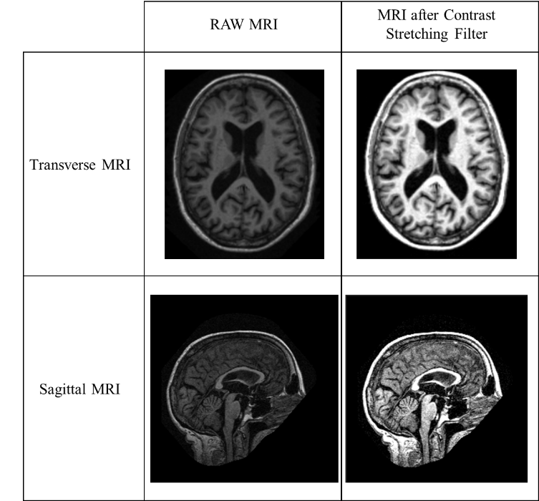

**Fig. 4.** MRI images before, and after applying the Contrast Stretching filter, respectively.

## 4.2 Sharpening Filter

A Sharpening filter is used to highlight fine detail in an image, and is a method that's inverse to blurring, to search out the distinction by the neighbourhood by the process of spatial differentiation.

The Derivative Operator: The strength of the response of a derivative operator is proportional to the degree of discontinuity of the image at the point at which the operator is applied.

First and Second Order Difference of 1D: The definition of the first-order derivative of a one-dimensional function f(x) is given by:

(2)

The second-order derivative of a one-dimensional function f(x) is given by:

When considering an image function of two variables, f(x, y), one also deals with partial derivatives along the two spatial axes.

Gradient Operator (4)

Laplacian Operator (5)

Effect of Laplacian Operator: Laplacian operator is a type of derivative operator. It therefore highlights gray-level discontinuities in a picture, while also deemphasizing regions with slowly varying gray levels. The Laplacian operator produce pictures that have gray edge lines and other discontinuities, all superimposed on a dark plain background. Fig. 5 shows the comparison between the MRI scans before and after the application of the Sharpening Filter.

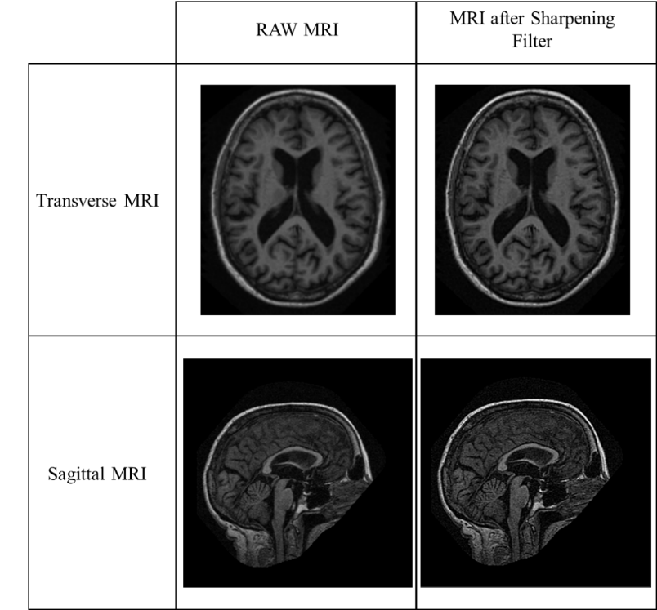

**Fig. 5.** MRI images before, and after applying the Sharpening filter, respectively.

## 4.3 High Pass Filter

The image is converted from spatial domain to frequency domain using Discrete Fourier Transform.

Discrete Fourier Transform:

Fourier transform of a 2D signal defined over a discrete finite 2D grid of size MxN. Fourier transform of a 2D set of samples forms a bidimensional sequence. The signal is periodized along both dimensions and the 2D-DFT can be regarded as a sampled version of the 2D DTFT. 2D DFT and IDFT:

where,

M, N: Image Size

x,y: Image pixel position

u,v: spatial frequency

Fig. 6 shows the comparison between the MRI scans before and after the application of the High-Pass Filter.

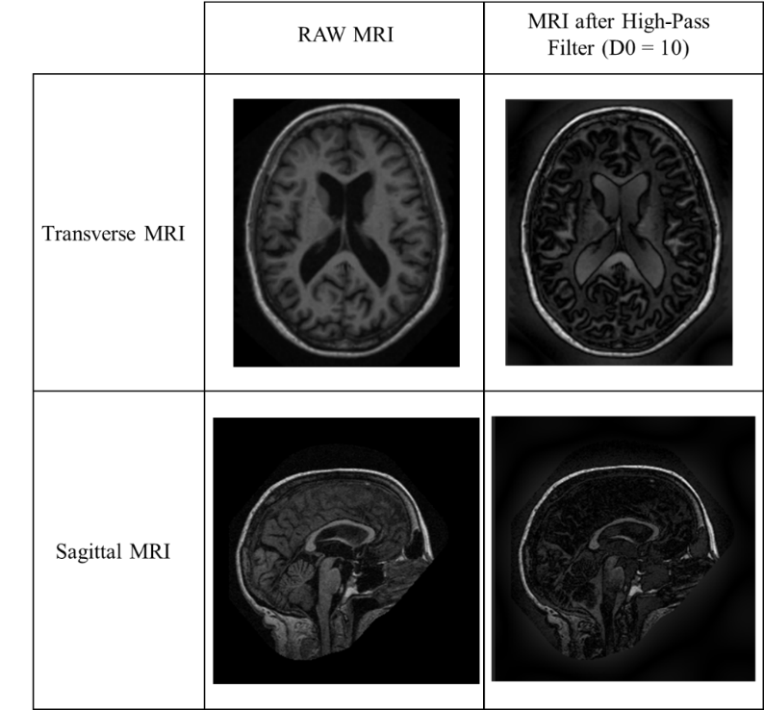

**Fig. 6.** MRI images before, and after applying the High Pass Filter with a cut-off d0 of 10, respectively

## 4.4 Anisotropic Diffusion Filter

Anisotropic Diffusion Filter (ADF) reduces image noise without removing edges, lines or fine details that are important for the interpretation of the image. The Anisotropic Diffusion Filter is similar to a Gaussian Filter, as both the filters are used to blur the image. While a Gaussian Filter blurs the entire image, irrespective of the lines, edges, or fine details, it also shifts the parts of the image outwards, the ADF preserves the lines, edges, and finer details (which can be tuned), and blurs region on the interior of the perimeter of the line, or edge present in the image, and preserves the position of the details in the image. ADF produces and image that is a non-linear and space-variant transformation of the original image.

Let denote a subset of the plane and be a family of gray scale images. is the input image. Then anisotropic diffusion is defined as

Where denotes the Laplacian, denotes the gradient, is the divergence operator and is the diffusion coefficient. For, the output image is available as and , with larger *t* producing blurrier images.

controls the rate of diffusion and is called the Diffusion coefficient. It is a function of the image gradient which preserves edges in the image.

The two functions for the diffusion coefficient are:

and

(10)

The constant Kappa, K controls the sensitivity to edges by controlling conduction as a function of the gradient. Kappa lies in the range of 0 to 100. If kappa is low small intensity gradients are able to block conduction and hence diffusion across steep edges. A large value reduces the influence of intensity gradients on conduction. Setting the diffusion coefficient, as an edge seeking function, the resulting equations smoothen within regions and prohibit it across strong edges. Hence the edges can be preserved while smoothening the internal regions. Using the Modified Perona-Malik equation (11), the unknown is convolved with a Gaussian inside the non-linearity to obtain the modified Perona-Malik equation (11).

(11)

where

Fig.7 shows the comparison between the MRI scans before and after the application of the Anisotropic Diffusion Filter.

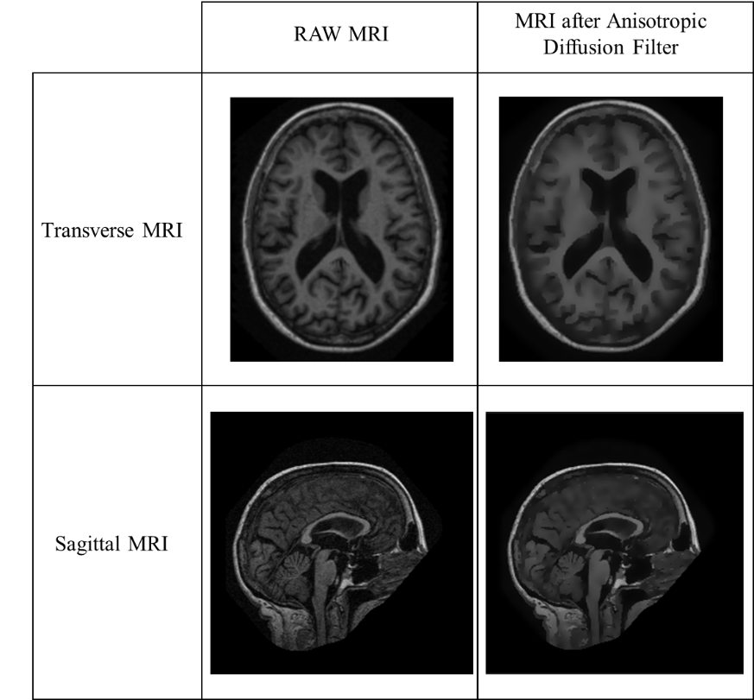

**Fig. 7.** MRI images before, and after applying the Anisotropic Diffusion filter, respectively.

***4.5 Series of Filters***

In this section, a combination of multiple aforementioned filters are used in a series. The MRI images are passed through two or more filters in order to further highlight the biomarker, which in this case is the Hippocampus. Only the best performing filters are used. Some combinations such as: Contrast Stretching Filter followed by the Sharpening Filter, Sharpening Filter Followed by the Anisotropic Diffusion Filter (ADF), Sharpening Filter followed by the Contrast Stretching Filter followed by the ADF, and vice versa. Fig. 8 shows the comparison between the MRI scans before and after the application of the two aforementioned Series of filters.

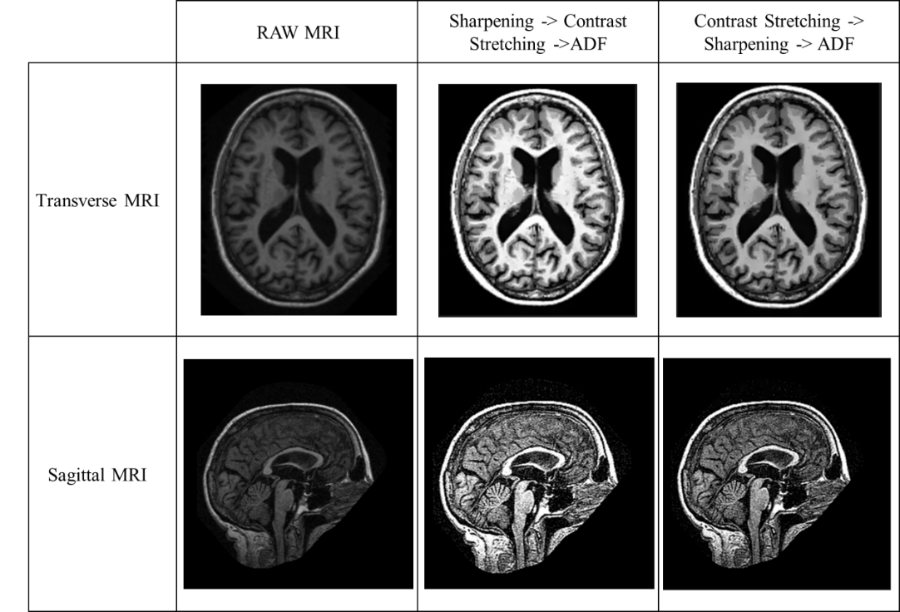

**Fig. 8.** MRI images before, and after applying the two Series of filters

1. **PROPOSED CONVOLUTIONAL NEURAL NETWORK MODEL**

The Neural Network model in the proposed study consists of 5 layers. The first 3 layers are convolutional and the last 2 layers are fully connected layers. Max Pooling layers are present following each convolutional layer, and Sigmoid activation functions are used in each layer.

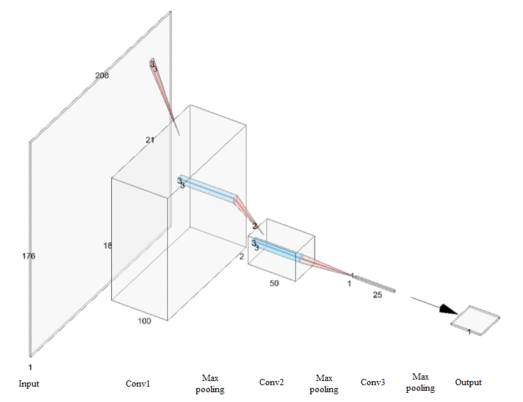

**Fig. 9.** Architecture of the Proposed Convolutional Neural Network Model

The detailed description of each layer and their respective parameters are mentioned in Table 1.

**Table 1.** Proposed Convolutional Neural Network Architecture

|  |  |  |  |  |  |  |
| --- | --- | --- | --- | --- | --- | --- |
| **Layer** | **Number of Filters** | **Filter Size** | **Stride** | **Padding** | **Size of feature map** | **Activation function** |
| Input | - | - | - | - | 208 x 176 x 1 | - |
| Conv 1 | 100 | 3 x 3 | 10 | same | 21 x 18 x 100 | Sigmoid |
| Max Pool 1 | - | 2 x 2 | - | valid | 10 x 9 x 100 | - |
| Conv 2 | 50 | 3 x 3 | 5 | same | 2 x 2 x 50 | Sigmoid |
| Max Pool 2 | - | 2 x 2 | - | valid | 1 x 1 x 50 | - |
| Conv 3 | 25 | 3 x 3 | 1 | same | 1 x 1 x 25 | Sigmoid |
| Max Pool 3 | - | 1 x 1 | - | valid | 1 x 1 x 25 | - |
| Flatten | - | - | - | - | 25 | - |
| Fully Connected (Output) | - | - | - | - | 1 | Sigmoid |

# **AlexNet**

AlexNet has 8 layers. The first 5 are convolutional and the last 3 are fully connected layers. In between we also have some ‘layers’ called pooling and activation.

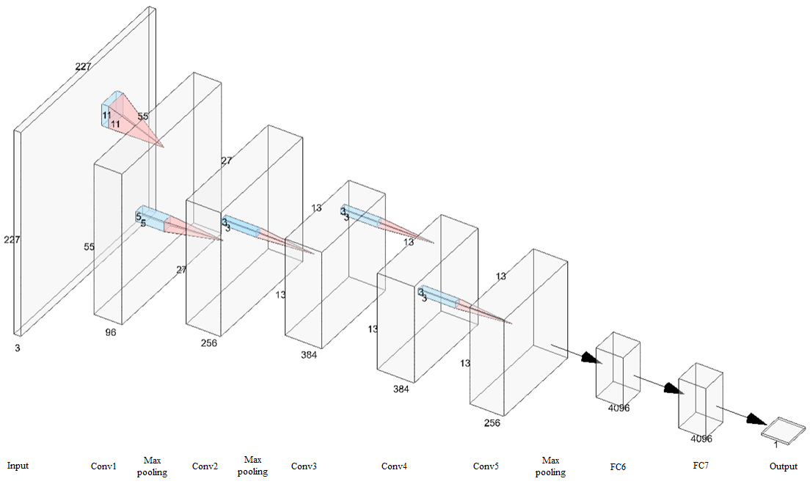

**Fig. 10** AlexNet Architecture

The detailed description of each layer and their respective parameters are mentioned in Table 2.

**Table 2.** AlexNet Architecture

|  |  |  |  |  |  |  |
| --- | --- | --- | --- | --- | --- | --- |
| **Layer** | **Number of Filters** | **Filter Size** | **Stride** | **Padding** | **Size of feature map** | **Activation function** |
| Input | - | - | - | - | 227 x 227 x 3 | - |
| Conv 1 | 96 | 11 x 11 | 4 | - | 55 x 55 x 96 | ReLU |
| Max Pool 1 | - | 3 x 3 | 2 | - | 27 x 27 x 96 | - |
| Conv 2 | 256 | 5 x 5 | 1 | 2 | 27 x 27 x 256 | ReLU |
| Max Pool 2 | - | 3 x 3 | 2 | - | 13 x 13 x 256 | - |
| Conv 3 | 384 | 3 x 3 | 1 | 1 | 13 x 13 x 384 | ReLU |
| Conv 4 | 384 | 3 x 3 | 1 | 1 | 13 x 13 x 384 | ReLU |
| Conv 5 | 256 | 3 x 3 | 1 | 1 | 13 x 13 x 256 | ReLU |
| Max Pool 3 | - | 3 x 3 | 2 | - | 6 x 6 x 256 | - |
| Dropout 1 | rate = 0.5 | - | - | - | 6 x 6 x 256 | - |
| Fully Connected 6 | - | - | - | - | 4096 | ReLU |
| Dropout 2 | rate = 0.5 | - | - | - | 4096 | - |
| Fully Connected 7 | - | - | - | - | 4096 | ReLU |
| Fully Connected 8 (Output) | - | - | - | - | 1 | Sigmoid |

# **RESULTS**

In this study, the classification is implemented via using both demented and non-demented (healthy) MRI images. The aim is to distinguish demented images from the non-demented images. According to the experimental results, the classification Accuracy of the Proposed CNN model is 99.21 %, Furthermore, the most commonly used performance metrics such as precision, recall, F1-Score, respectively are compared. Parameters obtained from the Confusion Matrix are, True Positive (TP), False Positive (FP), False Negative (FN), and True Negative (TN) represent correctly detected Alzheimer’s Disease, incorrectly detected Alzheimer’s Disease, incorrectly detected non-Alzheimer’s Disease, and correctly eliminated non-Alzheimer’s Disease, respectively. The formulae to calculate the aforementioned parameters is given below.

Accuracy: It is the ratio between the total number of correct predictions to the total number of predictions. It is given by:

Accuracy = (TP + TN) / (TP + TN + FP + FN) …(12)

Precision: It is the ratio between the total number of True Positive predictions to the total number of positive predictions. It is given by:

Precision = TP / (TP +FP) …(13)

Recall: It is the ratio between the total number of True Positive predictions to the total number of positive observations in the test dataset. It is given by:

Recall = TP / (TP + FN) …(14)

F1-Score: It is the harmonic mean of the mode’s precision and recall. It is used to evaluate binary classification models. It is given by:

F1-Score = 2*Precision*Recall / (Precision + Recall) …(15)

For best classification, Accuracy, Precision, Recall, and F1-Score should be maximized.

The performance parameters of the study are mentioned in Table 3.

**Table 3.** Performance evaluators of the proposed method with the pre-processing

|  |  |  |  |  |  |  |  |  |
| --- | --- | --- | --- | --- | --- | --- | --- | --- |
| **Model** | **MRI** | **Model Number** | **Filter/s** | **Epochs** | **Accuracy (%)** | **Precision** | **Recall** | **F1-Score** |
| Proposed  CNN  Model | Sagittal | 1 | None | 500 | 79.82 | 0.50 | 0.318 | 0.388 |
| 2 | Sharpening | 500 | 81.65 | 0.555 | 0.454 | 0.499 |
| 3 | Contrast Stretching | 400 | 84.4 | 66.67 | 0.454 | 0.902 |
| 4 | High Pass Filter | 1100 | 74.31 | 0.333 | 0.272 | 0.299 |
| Transverse | 5 | None | 100 | 87.16 | 0.642 | 0.818 | 0.720 |
| 6 | Sharpening | 900 | 86.24 | 0.666 | 0.636 | 0.651 |
| 7 | Contrast Stretching | 900 | 88.99 | 0.727 | 0.727 | 0.727 |
| 8 | High Pass Filter | 800 | 83.49 | 0.625 | 0.454 | 0.526 |
| 9 | Anisotropic Diffusion | 100 | 88.99 | 0.75 | 0.681 | 0.714 |
| 10 | ADF + Sharpening | 700 | 83.49 | 0.60 | 0.545 | 0.571 |
| 11 | ADF + C.S. | 100 | 90.83 | 0.772 | 0.772 | 0.772 |
| 12 | ADF + High Pass | 600 | 83.49 | 0.625 | 0.454 | 0.526 |
| **13** | **Sharpening + C.S. +ADF** | **100** | **99.40** | **0.988** | **1.00** | **0.994** |
| 14 | C.S + Sharpening + ADF | 100 | 94.83 | 0.80 | 0.727 | 0.761 |
| AlexNet | Transverse | 15 | None | 60 | 90.26 | 0.866 | 1.00 | 0.928 |
| 16 | Sharpening | 90 | 92.24 | 0.866 | 0.736 | 0.795 |
| 17 | Contrast Stretching | 90 | 91.37 | 0.827 | 0.827 | 0.827 |
| 18 | High Pass Filter | 80 | 91.49 | 0.725 | 0.554 | 0.628 |
| 19 | Anisotropic Diffusion | 10 | 91.99 | 0.85 | 0.781 | 0.714 |
| 22 | Sharpening + C.S + ADF | 60 | 92.26 | 0.866 | 1.00 | 0.928 |
| 23 | C.S + Sharpening + ADF | 62 | 87.16 | 0.625 | 0.909 | 0.740 |

A column chart comparing the various performance parameters of the five best performing models is presented in Fig. 12. Model 13 is the overall best performing model and is the Proposed Model.

**Fig. 12.** Comparison of the Top 5 models

Fig. 13 shows the Region of Convergence (ROC) curve of the proposed model (Model Number 13 from Table 3). The ROC curve is sharp and has an area of 1.0, which is the maximum. It denotes that the proposed model has perform well.

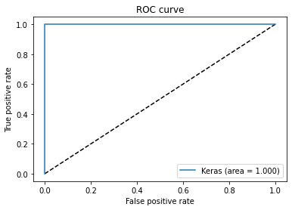

**Fig. 13.** ROC Curve of the proposed model

**Table 4** Performance of the proposed model on the training, and the testing dataset.

|  |  |  |  |  |
| --- | --- | --- | --- | --- |
|  | **Training Dataset** | | **Testing Dataset** | |
| **Actual** | **Predicted** | **Actual** | **Predicted** |
| **Number of observations** | 504 | 504 | 168 | 168 |
| **Number of True Positives** | 252 | 248 | 84 | 83 |
| **Number of True Negatives** | 252 | 252 | 84 | 84 |
| **Number of False Positives Predicted** | 0 | | 0 | |
| **Number of False Negatives Predicted** | 4 | | 1 | |
| **Accuracy (%)** | 99.21 | | 99.4 | |
| **Precision** | 0.9844 | | 98.82 | |
| **Recall** | 1.00 | | 1.00 | |
| **F1-score** | 0.9921 | | 0.9941 | |
| **Loss** | 0.03571 | | 0.02312 | |

The accuracy of the proposed work is compared against various existing approaches in the area of detection AD, and the results are highlighted in Table 5. It could be observed that the proposed method is advisable when compared to other methods.

# **Table 5** Comparison of classification accuracy

|  |  |  |
| --- | --- | --- |
| **Model** | **Method** | **Accuracy (%)** |
| AlexNet | Sharpening + C.S. + ADF | 92.26 |
| GoogLeNet [4] |  | 88.99 |
| ResNet50 [4] |  | 88.69 |
| AlexNet [4] |  | 94.64 |
| Scratch Trained [4] |  | 98.51 |
| MCapNet [8] |  | 92.39 |
| **Proposed CNN Model** | **Sharpening + C.S. + ADF** | **99.40** |

# **CONCLUSION**

Brain disorder can be diagnosed from MRI scans using Convolutional Neural Networks. The results can be further enhance using selecting appropriate Pre-Processing techniques, as well as Data Augmentation methods. The proposed model has produced an Accuracy of 99.40%, with a Precision of 0.9884, and a Recall of 1. These results are highly accurate and has successfully minimized misclassifications to an appreciable extent, which are required for such types of classifications. The accuracy of the model with no Pre-Processing has produced an accuracy of 87.16, and an f1-score of a mere 0.72. When compared to these results to the best model, it is evident that Pre-processing has had a major impact on improving the model performance. While the AlexNet model has performed well, and has produced a Recall of 1.00, it has a lower Precision value than that of the proposed model. The high complexity of the architecture of AlexNet may be the reason behind this. Furthermore, the AlexNet model took 60 epochs to learn the data, which is quite a lot more than usually required by it, and the losses increase significantly as the model was trained for more than 60 epochs. Comparing the results, it can be seen that the Proposed model has outperformed the AlexNet model when trained on the same dataset as used in the study. Training the Proposed CNN model on a larger dataset will make it more robust, and can be used by the Medical Professionals worldwide to accelerate the diagnosis of Alzheimer’s Disease.

# **REFERENCES**

[1] WHO 2020, Dementia - Key Facts. https://www.who.int/news-room/fact-sheets/detail/dementia

[2] Mayoclinic 2019, Diagnosing Alzheimer's: How Alzheimer's is diagnosed. https://www.mayoclinic.org/diseases-conditions/alzheimers-disease/in-depth/alzheimers/art-20048075

[3] Marcus, D. S., Wang, T. H., Parker, J., Csernansky, J. G., Morris, J. C., & Buckner, R. L. 2007. Open Access Series of Imaging Studies (OASIS): cross-sectional MRI data in young, middle aged, nondemented, and demented older adults. Journal of cognitive neuroscience, 19(9), 1498–1507. <https://doi.org/10.1162/jocn.2007.19.9.1498>

[4] Gerardin, E. 2012. Morphometry of the human hippocampus from MRI and conventional MRI high field.

[5] Shijie, J., Ping, W., Peiyi, J., & Siping, H. 2017. Research on data augmentation for image classification based on convolution neural networks. 2017 Chinese Automation Congress (CAC), 4165-4170.

[6] Khagi, Bijen & Kwon, Goo-Rak 2019. CNN Model Performance Analysis on MRI Images of an OASIS Dataset for Distinction Between Healthy and Alzheimer’s Patients. IEIE Transactions on Smart Processing & Computing. 8. 272-278. 10.5573/IEIESPC.2019.8.4.272.

[7] Zingale, R., & Zingale, A. 1998. Detection of MRI brain contour using isotropic and anisotropic diffusion filter. A comparative study. Journal of neurosurgical sciences, 42(2), 111–114.

[8] Basheer, S., Bhatia, S., & Sakri, S. 2021. Computational Modeling of Dementia Prediction Using Deep Neural Network: Analysis on OASIS Dataset. IEEE Access, 9, 42449-42462.

[9] Perona, P., & Malik, J. 1990. Scale-Space and Edge Detection Using Anisotropic Diffusion. IEEE Trans. Pattern Anal. Mach. Intell., 12, 629-639.